**Project title: COVID-19 Symptom Checker**

Group Members:

Shadab Iqbal (ID 19101072)

Ishrat Jahan Mitu (ID 19101087)

Yeasif Bin Noor (ID 19101085)

Khondoker Al Muttakin (ID 19101525)

**Short Description of the Project**

This is basically a circuit which will give only one output. Either the patient will be diagnosed as Positive or negative. The bulb will be turned on if the patient is diagnosed with positive.

First of all, there are 5 inputs for 5 symptoms. We will need 5 switches for these.

* If the patient has fever. [Switch will be ON if the patient has this symptom]
* If the patient has difficulty in breathing. [Switch will be ON if the patient has this symptom]
* If the patient has dry cough [Switch will be ON if the patient has this symptom]
* If the patient has throat pain [Switch will be ON if the patient has this symptom]
* If the patient has body pain [Switch will be ON if the patient has this symptom]

For being tested positive with COVID-19, one of the requirements is that the patient must have fever, difficulty in breathing, dry cough along with either throat pain or body pain.

So the equation for this is like:

Fever && Difficulty breathing && Dry cough && (Throat pain || Body pain)…… equation (i)

Again, there will be switch for intensity level also. The fever has no intensity level. What matters only is that if the patient has fever or not. But there are intensity level for other symptoms. We must have to take the intensity level for difficulty breathing and dry cough and we will take only 1 intensity level from throat pain and body pain. The intensity level will be measured by a 2-bit binary number. So, we will need (3x2) = 6 switches for inputting the intensity level of those 4 symptoms. For example, for a particular symptom, there can be 3 levels of intensity. Those 3 levels in binary number are: (01)2, (10)2, (11)2.

Then we will check if the total sum of those three symptom’s intensity exceeds (0101)2 or not.

So, the equation for this is like:

Intensity of {Difficult breathing + Dry cough + (Throat or Body pain)} > (0101)2..............(ii)

Therefore we can conclude by summing up that, if both the Equation (i) and (ii) are TRUE,

Only then the patient will positively diagnosed with COVID-19(Bulb ON). If not, then he/she will be diagnosed as negative (Bulb OFF).

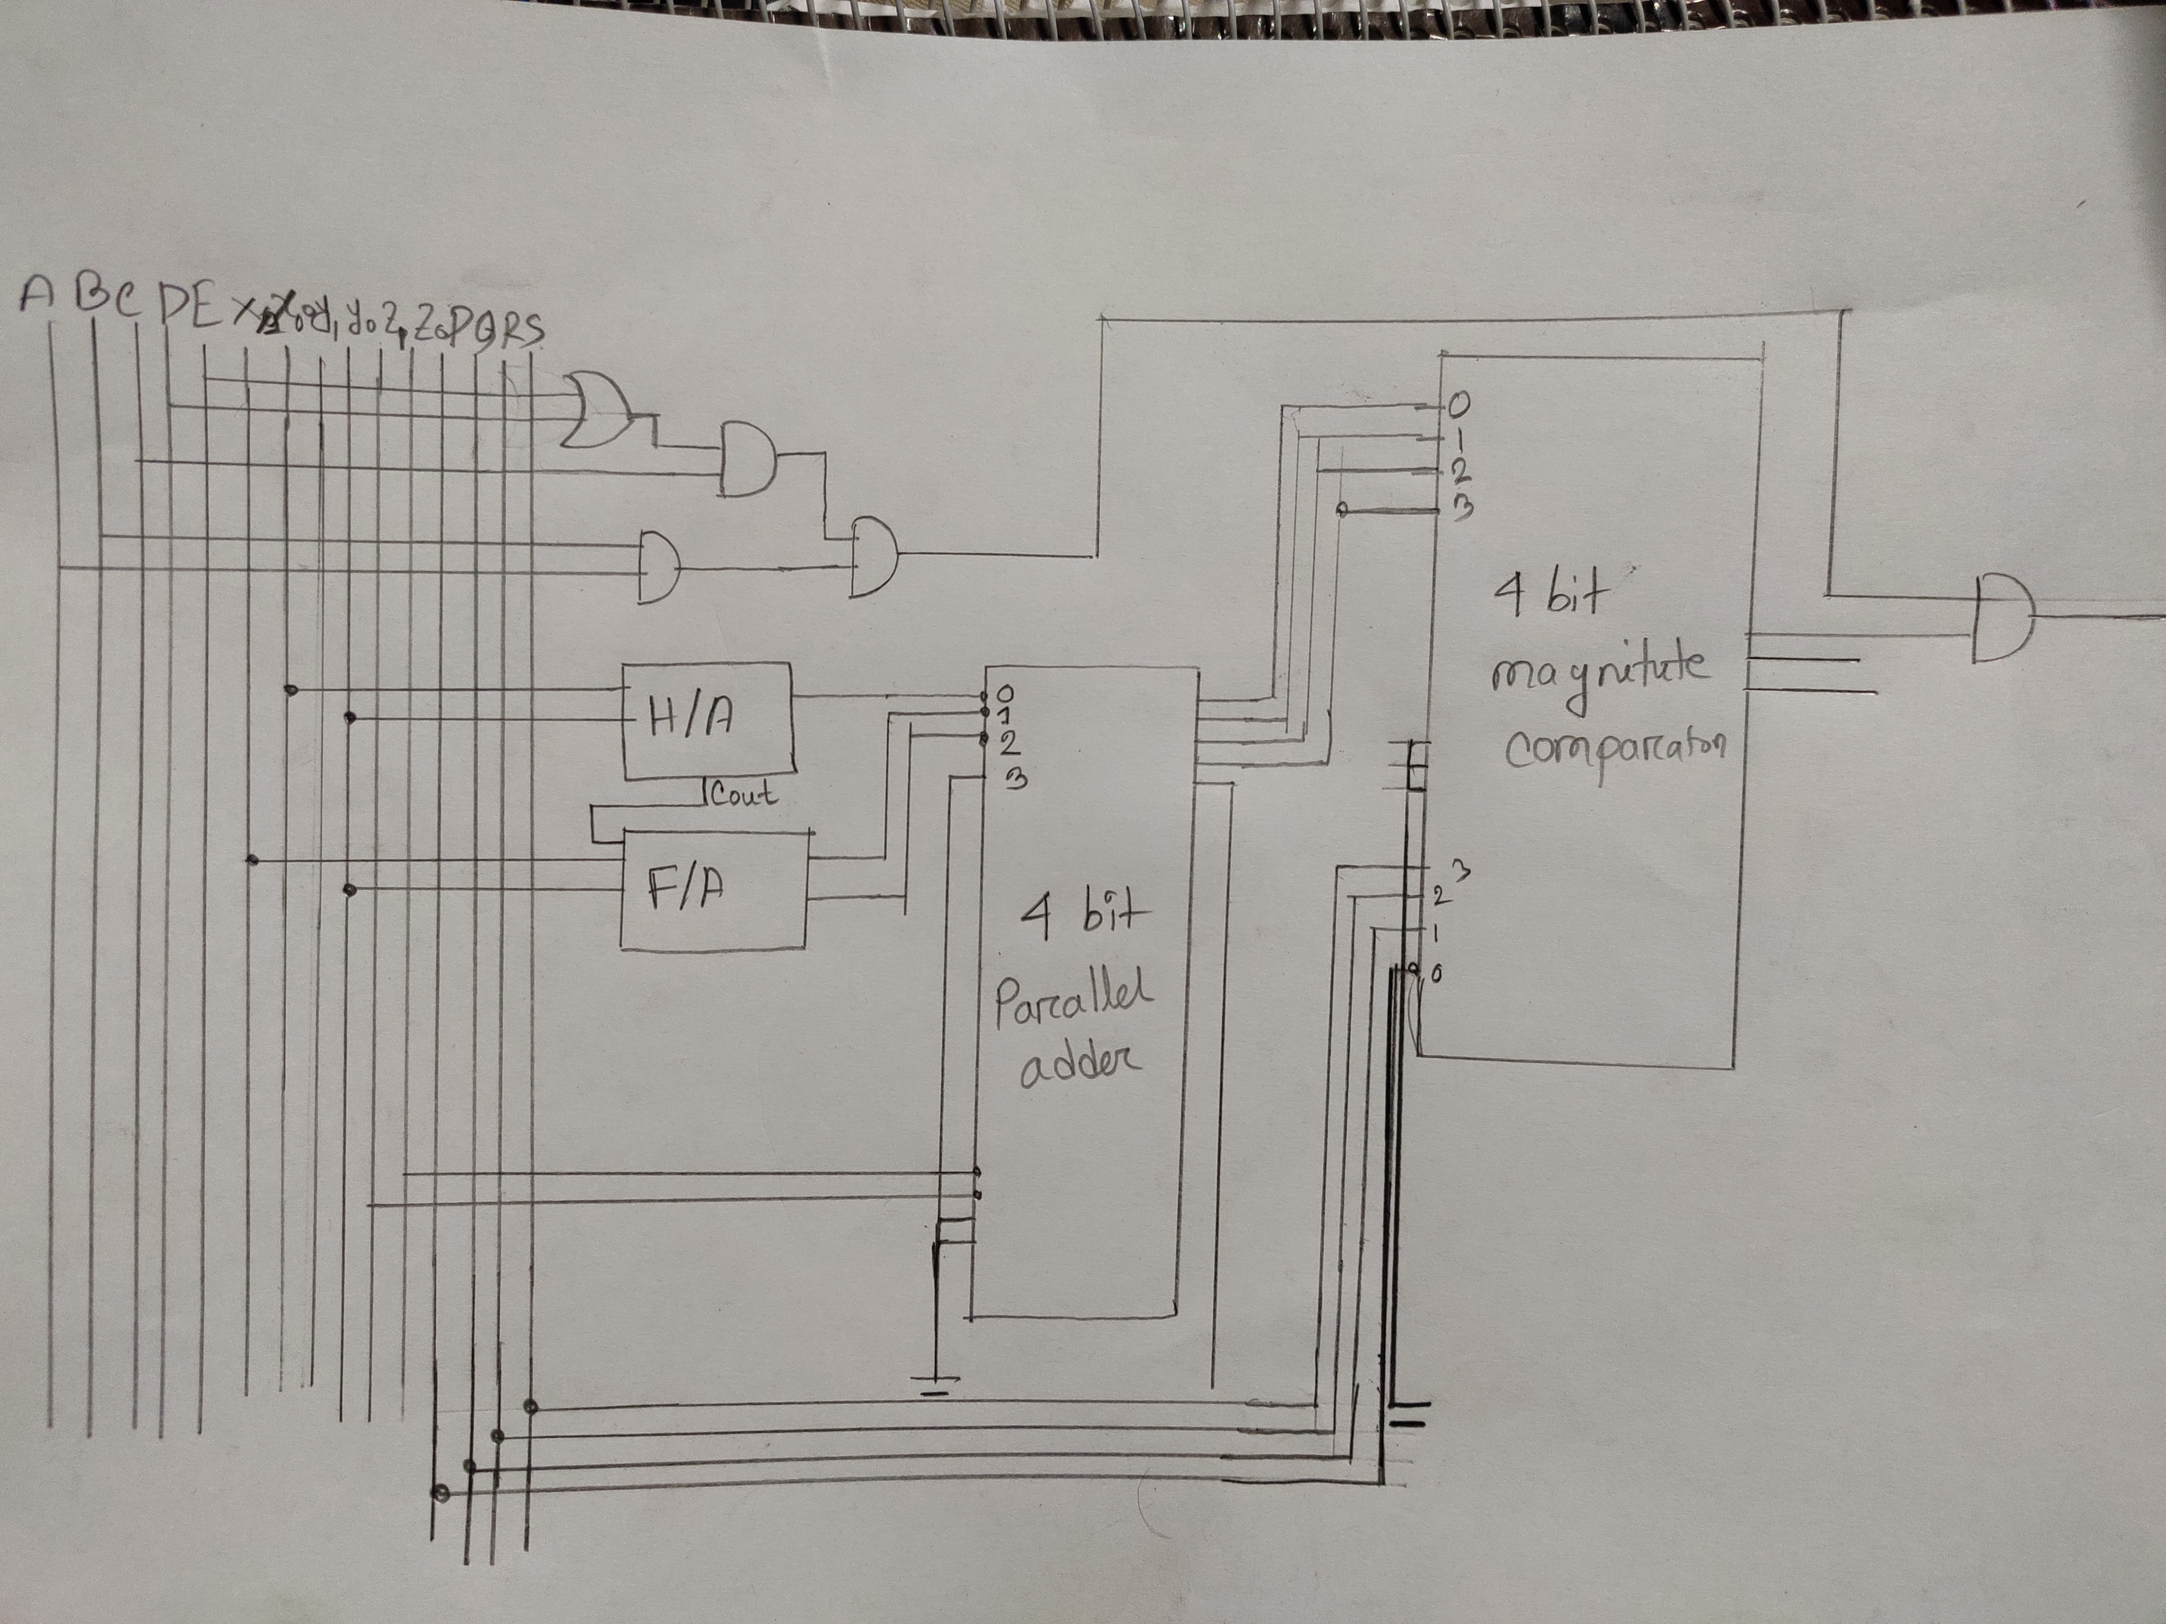

A = Fever; B = Dry cough; C = Difficult breathing; D = Throat pain; E = Body pain;

X = Dry cough Intensity; Y = Difficult breathing Intensity; Z = Throat or Body pain Intensity;

P,Q,R,S = These are the bits to set the limit. These bits are constant and their value is 0,1,0,1 respectively. If the summation of the intensity levels cross this limit, it will output 1 or True.